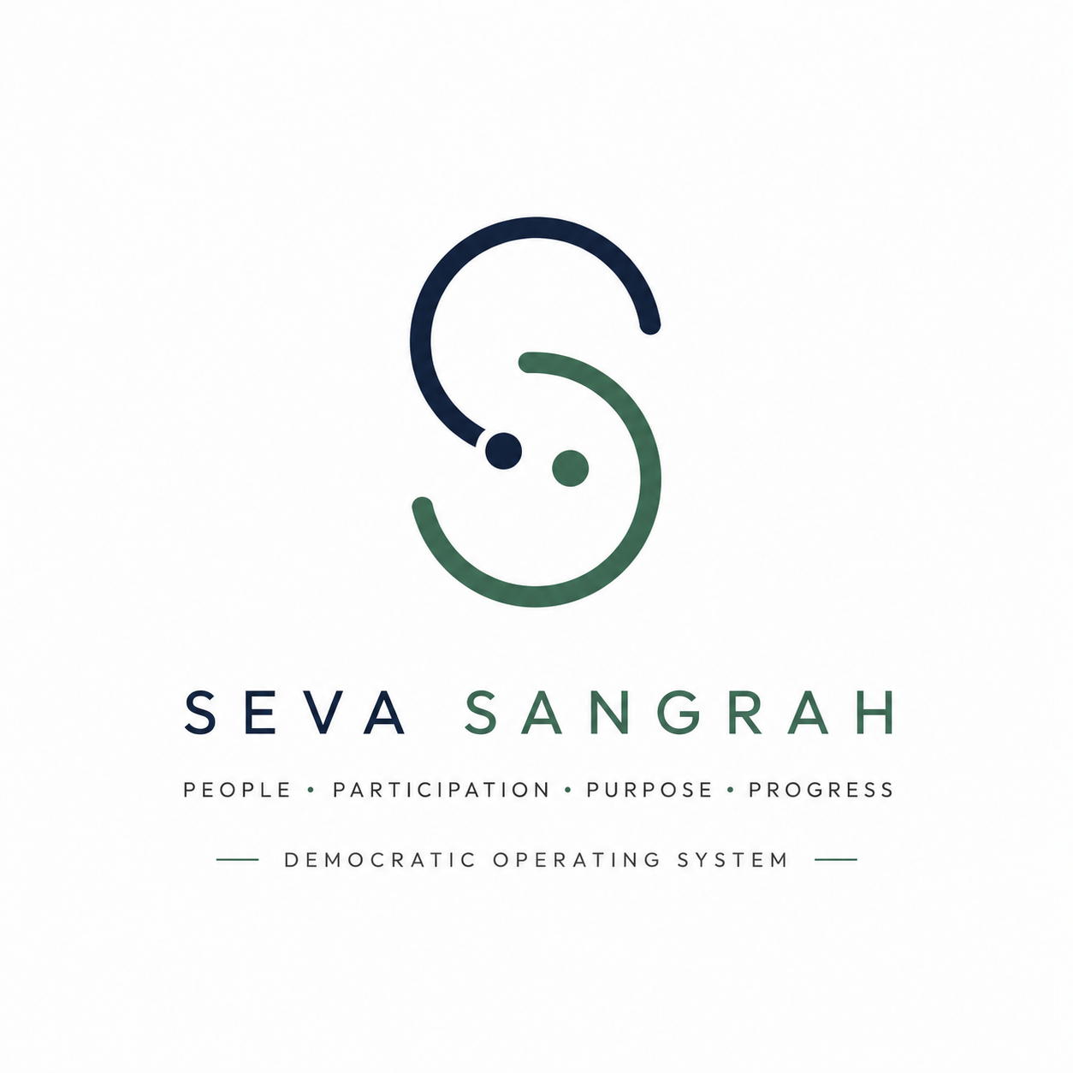
AN INTRODUCTION

THE PREAMBLE TO THE CONSTITUTION OF INDIA · 26 NOVEMBER 1949
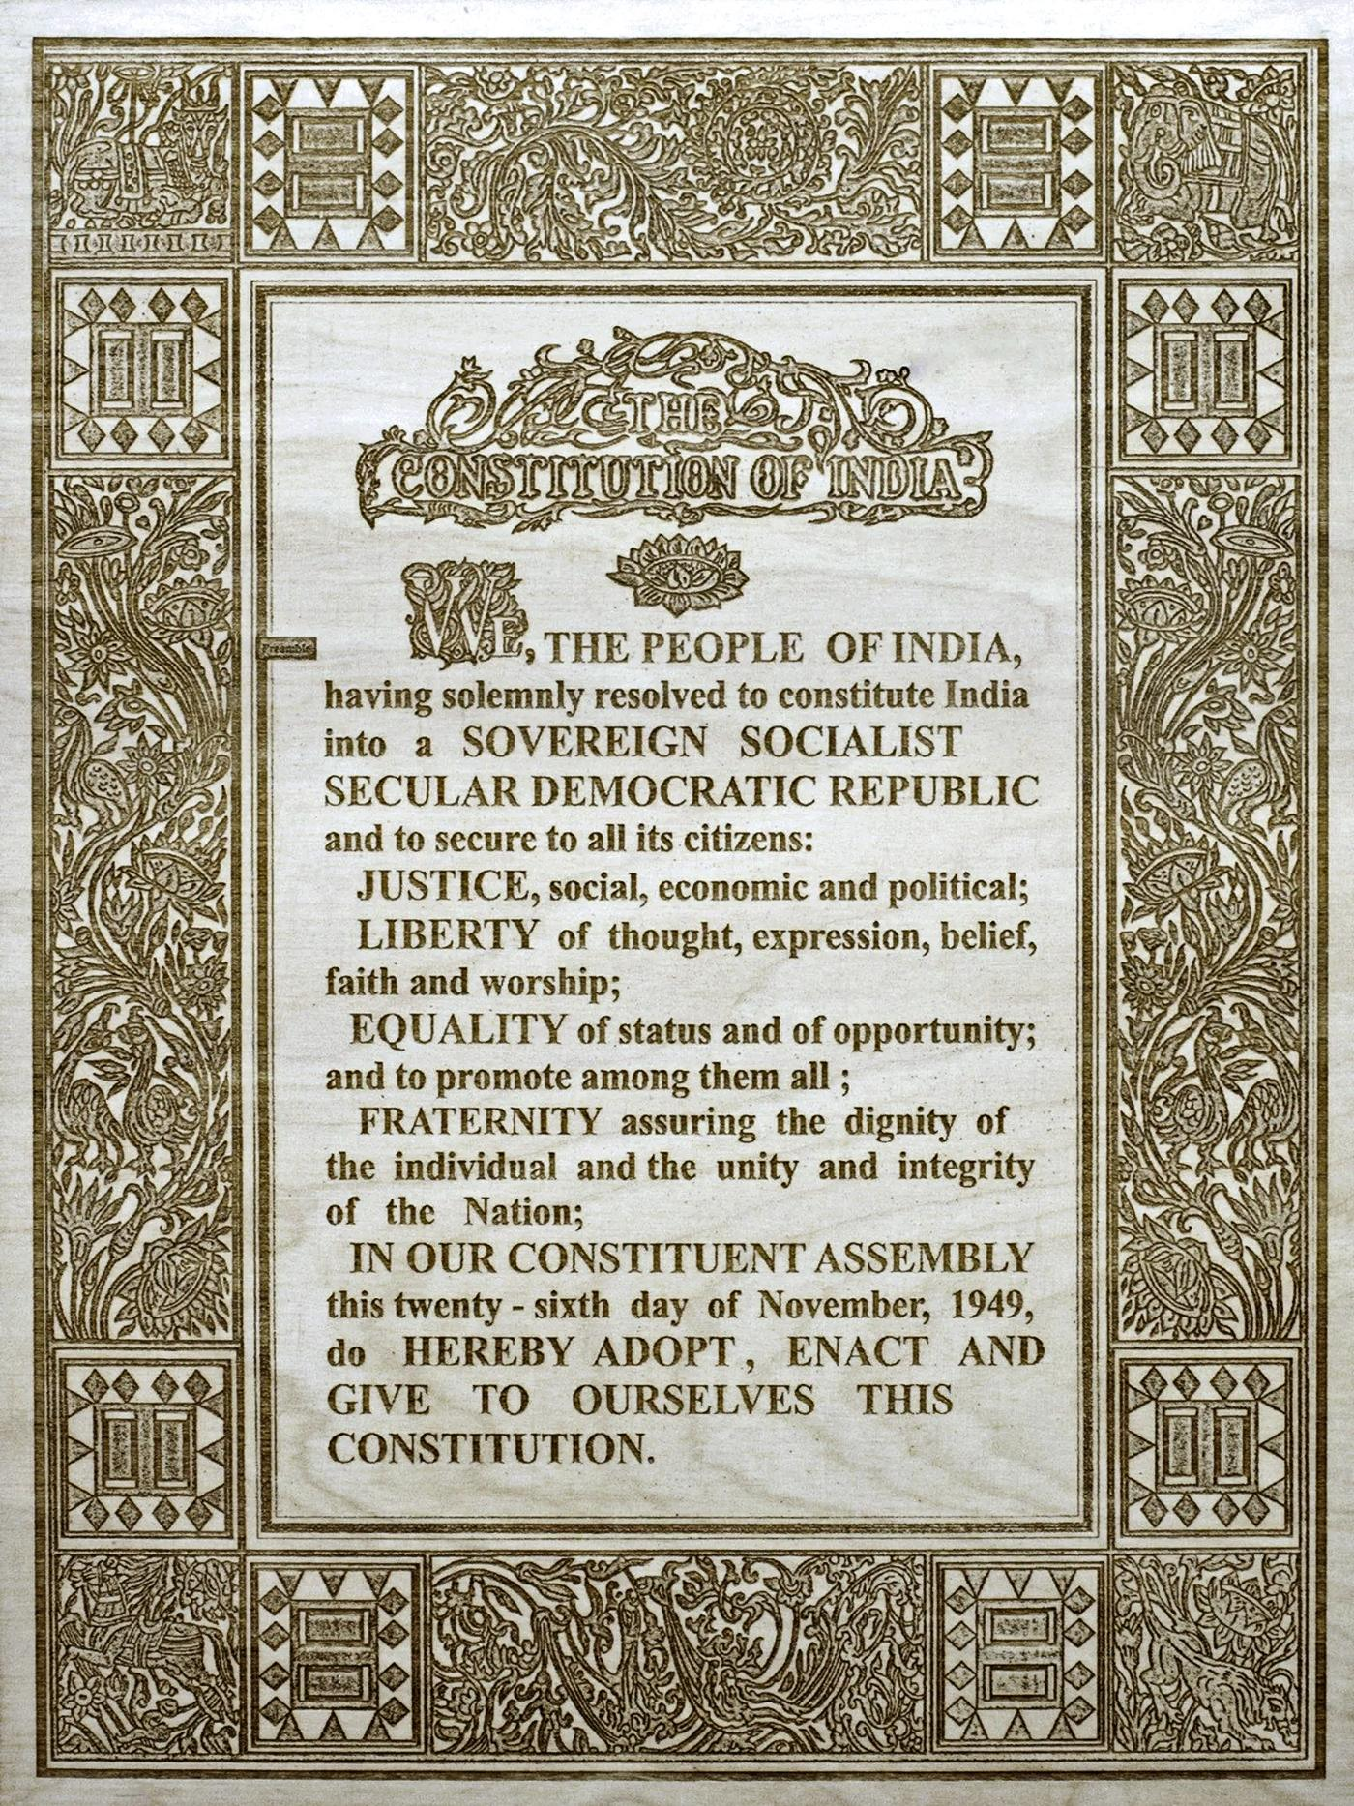
This is where the idea comes from.

01 Why This Exists
Every day, we interact with systems that remember us.
When I leave my office in the evening, Google Maps often knows that I'm heading home before I ask for directions. It has learned my routine over time and suggests the best route based on current traffic.
Uber remembers the places I travel to most frequently.
Blinkit remembers what I usually order.
Swiggy remembers the food I enjoy.
Banks remember my spending patterns well enough to detect unusual transactions.
Streaming platforms remember what I watch and recommend content accordingly.
These systems become more useful because they remember. Memory allows them to learn. Learning allows them to improve.
Now consider one of the most important systems we have ever created: the Republic.
— Does it remember the promises made before elections?
— Does it remember which public servant consistently solved difficult problems?
— Does it remember which elected representative quietly delivered results over many years?
— Does it remember the ideas contributed by millions of citizens?
— Does it remember which institutions improved and which repeatedly failed?
In most cases, it does not.
There is a deeper reason this matters. Turn back to the page you just read. Every public servant — from the Prime Minister to the sanitation worker sweeping a street at dawn — is hired by the people, paid from the people's taxes, and answerable to the people. Not the other way around.
But an institution that forgets cannot be held answerable. When there is no memory of what was promised, no record of who delivered and who did not, the distance between a public servant who serves and one who has quietly begun to rule becomes impossible to see — and even harder to correct.
Public servants are hired by the sovereign people to serve them — not to rule over them.
Seva Sangrah exists to make sure the Republic never forgets that fact.
Much of public life depends on fragmented records, individual memory, media coverage and changing political narratives. Valuable knowledge is constantly lost, forcing citizens, governments and institutions to rediscover the same problems repeatedly.
The Democratic Operating System begins with a simple idea:
A Republic that remembers can learn. A Republic that learns can improve.

02 What Is the Democratic Operating System?
The Democratic Operating System is not a software application. It is a philosophy for helping the Republic learn continuously.
It views the Republic as a living system composed of four participants. Each contributes knowledge. Each learns from the others. Each improves over time.
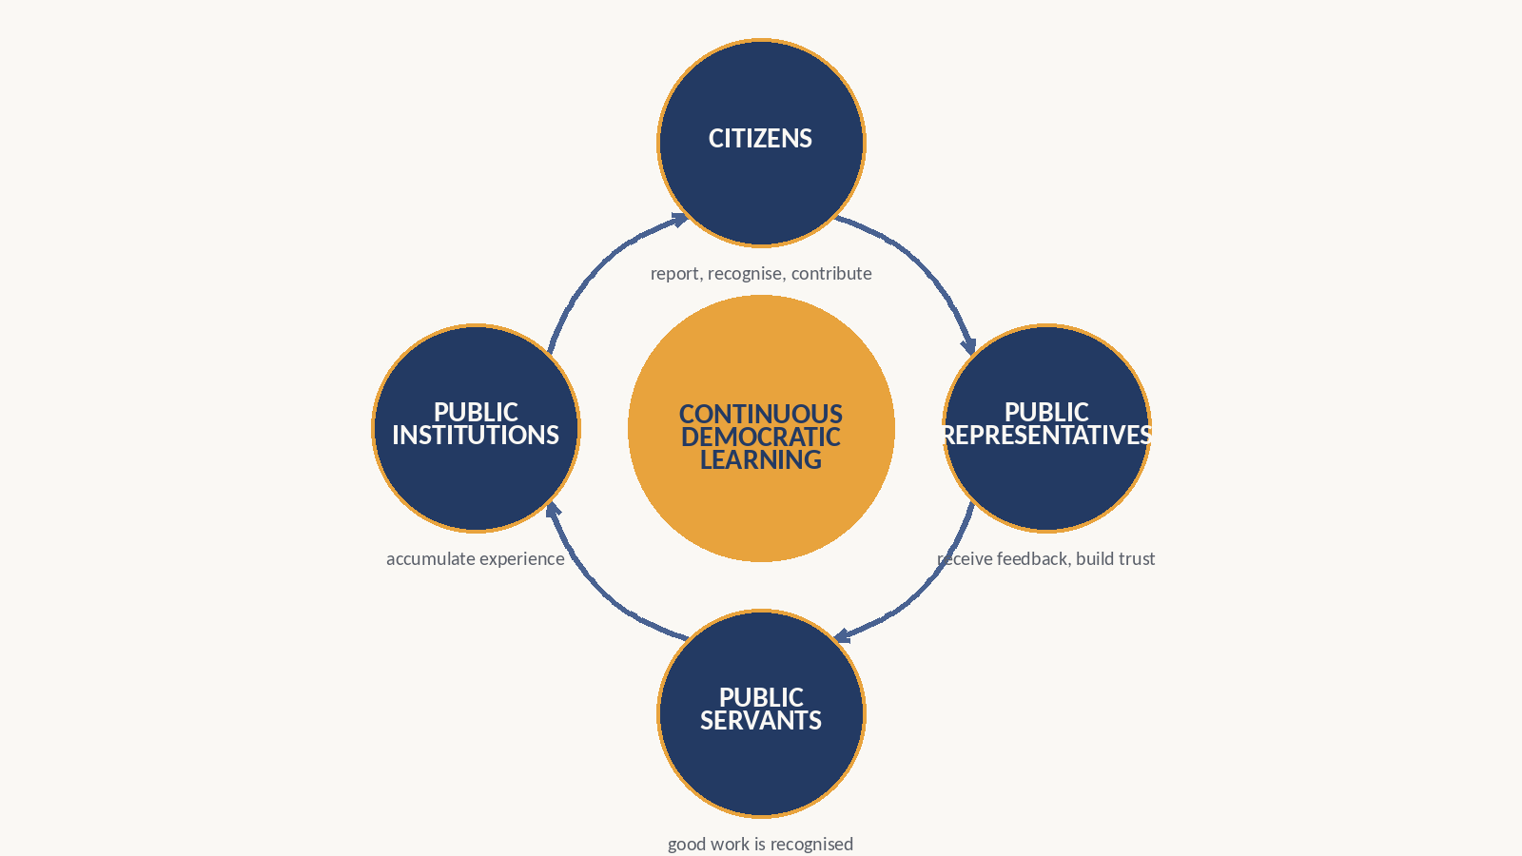
Seva Sangrah is one implementation of this philosophy.
Today, that implementation may include a website, a mobile application or WhatsApp. Tomorrow it may use technologies that do not yet exist. The implementation is a line drawn in sand, not a line carved in stone. The philosophy remains constant even as technology evolves.
Seva Sangrah is designed to help citizens report issues, recognise exemplary public service, track public commitments, contribute ideas, preserve institutional memory and identify emerging public leaders.
It is not:
✗ a complaint portal
✗ a politician rating app
✗ a political party
✗ an anti-government movement
✗ a replacement for constitutional institutions
✗ social media
✗ a CRM for politicians
✗ or simply another civic-tech startup
It is an attempt to create continuous democratic learning.
The objective is not to help one political party defeat another.
The objective is to help the Republic become better at learning from itself.

03 Where Does This Lead?
If the Republic can remember, it can improve.
Citizens | Their participation contributes to a shared institutional memory instead of disappearing after every election.
Public Representatives | They receive structured feedback, understand constituents' priorities and build trust through visible public service.
Public Servants | Good work is recognised, knowledge is preserved, and institutions learn instead of repeatedly starting over.
Public Institutions | They accumulate experience rather than losing it whenever leadership changes.
Over time, this creates something larger than a technology platform.
It creates a Republic that continuously learns.
It also creates an opportunity to discover and develop public leadership based on demonstrated service rather than visibility, wealth or political inheritance. Political parties remain free to compete for power, but they compete by recruiting better leaders, not merely by controlling access to leadership.
This is why Seva Sangrah is only the beginning. It is one implementation of a larger philosophy.
Strip away the technology, and the whole idea comes down to one sentence: a public servant who knows they are being watched by the people who employ them will serve those people — and a public servant who knows they will never be checked, eventually, will not.
The long-term ambition is not to build another app. It is to help build a Republic that remembers, learns and continuously improves — a Republic where every public servant, at every level, finally answers to the sovereign people who hired them.
Don't just live in a democracy.
Help build one.

